Battlebot Design Calculations
Satvik Sarode

Watch the ‘Team just cause electronics’ combat robot electronics series.

- Wheel motors
-The largest and sturdiest robot wheels that can be found on the internet are 10 cm in dia.
The weight of the bot can be maximum 15 kg, even if during engagement the weight on the wheel doubles, i.e. becomes 30 kg, with a distributed load of 7.5 kg on all four wheels, the max. Torque on each wheel = .375 Nm or 37.5 Ncm.

This link has a good explanation of robot velocity, rpm and subsequent torque requirements.
https://www.societyofrobots.com/mechanics_dynamics.shtml

Wheel links:
https://roboticsdna.in/product/104-6mm-wheel/ 4.6 cm thickness
https://roboticsdna.in/product/102-wheel/ 2 cm thickness

Max rpm has been calculated from assuming that the diagonal of the arena has to be traversed in 6 seconds. V = (16ft*sq.rt.(2))/7 = 1.14945 m/s
N = V/2*pi*R = 7.3177 rev/s = 219.5 rpm

For a typical robot on flat terrain, magnitude of accl. Is suggested to be half of that of velocity, a = 0.5747 m2/s

Torque = force *wheel radius

“My personal rule is if you have 2 motors on your robot, make sure the stall torque on each is enough to lift the weight of your entire robot times your wheel radius.” - society of robots combat electronics guide

By this, stall torque = 15 x 9.8 x 0.05 = 7.35 Nm

https://www.societyofrobots.com/RMF_calculator.shtml

The above inputs has been input into RMF calculator from societyofrobots. Any motor that satisfies the RMF requirement is suitable for us. (Even a 500 rupee motor does satisfy our requirements)

RMF = 6.9 kgmr/s

Brushed Motors that satisfy this requirement are in the 2000-2500 rupee range

Brushless motors do that for half the price.

- Drum spinner motors
Since these will engage with the other bot, we need motors which will not heat up or melt upon reaching high temperatures under a large amount of torque requirement.

The drum spinner motor needs to be such that even if the full weight of the opponent bot is placed on it, it will still overcome it and rotate, damaging the other robot. Drawing a very crude FBD, this represents the extreme situation when the other bots weight is completely on the drum spinner, which will never actually happen.

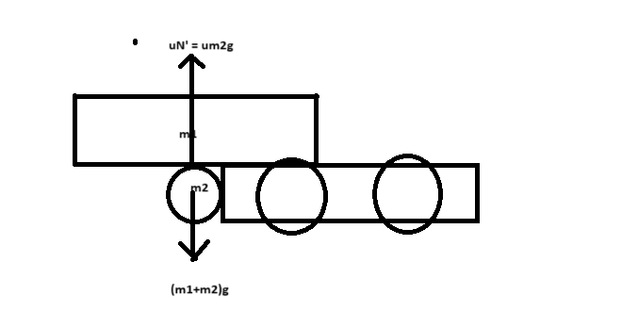
Max. weight on drum spinner = uM2g where M2 can be maximum 15 kg, and u is rarely greater than 1, m2g = 147, with a safety factor of 2, it can be maximum 294 N.
Torque = 294 x radius of drum spinner, which cannot be larger than the radius of the wheels = 294 x 0.05 = 14.7 Nm
Which is way too high,(Thus the entire calculation you read is redundant) ,so we will just need a very powerful (high torque) motor.

- ESC
Amp rating should be more than amps drawn by motor at max load, and the ones which are very small will not provide the amperage that they have been specified for, since too less area for heat dissipation.
ESCs also have an inbuilt BEC for receivers, check the voltage and current rating on that.

Good drone escs rated 40 amps under 1000 rupees are available if we use brushless motors.

- Batteries

https://www.youtube.com/watch?v=arOXg7y6r8k
Aman bhaiya suggested using individual cells instead of single large batteries to reduce weight.

LiPo batteries of 11.1V and upto 3000mAh are available at around 2000 rupees.
We need to pay attention to the discharge rating to make sure that our bot lasts the amount of time required for our competition.

- Receiver and Transmitter
The receiver and the transmitter need to operate under the same protocol. Battlebots
need RC systems with at least 3 channels to operate the 2 drive motors and a weapon motor.
The most popular affordable transmitter brand is Flysky, which is not very high end, but recommended for beginners.
Receivers are generally powered by an ESC, so the current rating of ESC should be accordingly decided. Must look for receivers with forward/reverse/sideways control, and also a compliant trip circuit.
If we use brushless motors, we can just use R/C equipment used for drones.
After actually having the components in hand, we need to do binding and mixing to operate it properly.

Final components list and budget:

- Flysky CTB6 transmitter with receiver
https://robu.in/product/ct6b-flysky-2-4ghz-6ch-transmitter-wfs-r6b-receiver-mode-2/
2535/-
If we opt for Brushed motors, I have listed the ones we can buy below, but brushless motors are in general more efficient, and will last longer, and have a lot of cheap escs available online. But I can't seem to find BLDCs online that will fit in our budget.
- Wheel motors:
https://robu.in/wp-content/uploads/2020/10/performance-PG45775128000-19.2K-1.pdf
2299 x 2 =4598/-
- Weapon motor:
https://robu.in/product/orange-planetary-gear-dc-motor-12v-100-rpm-294-3-n-cm-pgm45775-71-2k/
2399/-
- Controller
We will either need 3 ESCs of 50 amps each or microcontrollers and dual and single motor drivers.
For brushed motors, escs are not available online, thus microcontroller+motor driver is a safer, and cheaper option.

https://robu.in/product/dual-channel-enhanced-13amp-dc-motor-driver-30a-peak/
1900/-

https://www.amazon.in/permanent-guarantee-Arduino-Uno/dp/B0044X2E5S/ref=pd_sbs_d_sccl_3_5/260-9709570-6968445?pd_rd_w=kMGRz&content-id=amzn1.sym.a9e12e68-4e49-43d0-a6b4-fd1619ccac52&pf_rd_p=a9e12e68-4e49-43d0-a6b4-fd1619ccac52&pf_rd_r=D21R11C32TRBBDD0EFM5&pd_rd_wg=QQ1O9&pd_rd_r=61b0b6c2-3727-4a48-bffc-6737cdc2389a&pd_rd_i=B0044X2E5S&psc=1
2950/-

https://robokits.co.in/motor-drives-drivers/rhino-cytron-dc-motor-drivers/cytron-dc-motor-driver-5v-30v-13amp-md10c-original
1121/-

- Battery :
If we want a single battery :
https://robu.in/product/orange-8000mah-3s-30c60c-lithium-polymer-battery-pack-lipo/?gad_source=1&gclid=Cj0KCQiArrCvBhCNARIsAOkAGcXe_bux9xZMRReOZUE0lFAObe6r3xw4dz7-wztTFbCphFXdfWrNfJgaAlpQEALw_wcB
5250/-

